NEW TAIPEI CITY INTERNATIONAL ART VILLAGE
HOUSE OF MEMORY PROJECT
Prospectus for In-Residence Open Audition Application
14 September 2020 – 31 August 2021
I. Purpose of Project
The New Taipei International Art Village (NTIAV) is located in Tamsui, famous for its scenic mountains and the sea. The Art Village was a training center of the Taiwan Golf and Country Club, the first golf course in Taiwan and nearby scenic spots include the Hobe Fort, the Drop of Water Memorial Hall, the Cloud Gate Dance Theatre, and the Tamsui Golf Club. NTIAV is the closest to nature among all these nearby scenic spots. NTIAV is currently managed and operated by the New Taipei City Government Tamsui Historical Museum.
To encourage artistic creation, the studio space at the New Taipei International Art Village is provided as a base for creative work, allowing artists to experience Tamsui's slow living, through in-residency in the Village and to participate in the renovation of old mansions. The theme of the selection is "Memory". Artists are invited to present a plan for the exhibition and retrospective of historical sites. The program is carried out at the Former Residence of Tamsui Township Head Tada Eikichi and the Japanese Police Affairs Dormitories. The theme of the exhibition combines the historical, cultural and living aspects of Tamsui with its geographical environment. Artists interested in the project are welcome to apply and participate in the selection of resident artists at the New Taipei City International Art Village.
II. The environment at the In-Residence Village
(1) NTIAV and its surrounding landscape
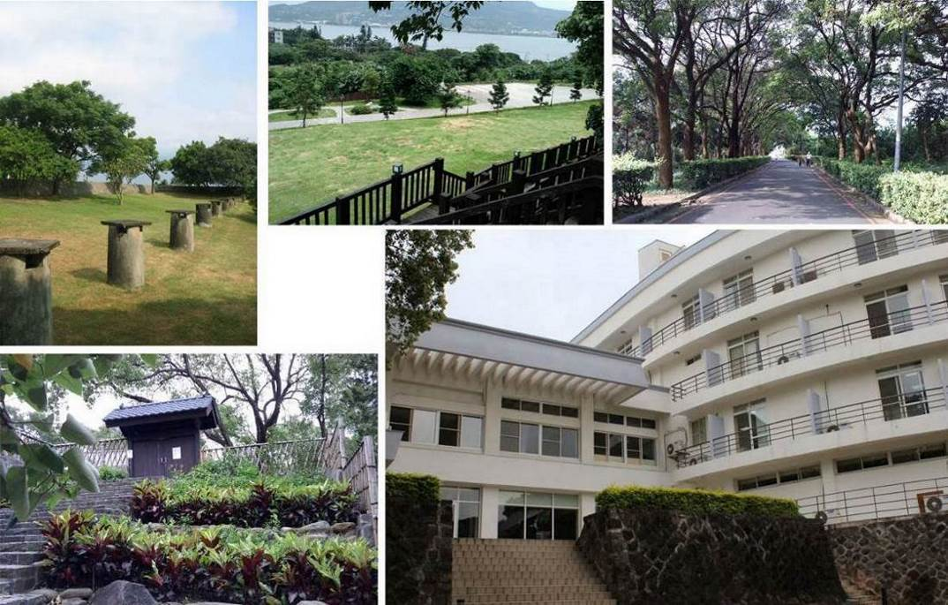
NTIAV address: No. 32-2, Lane 6, Section 1, Zhongzheng Road, Tamsui District, New Taipei City新北市淡水區中正路一段6巷32之2號
The New Taipei City International Art Village is located on the third floor, whereas the In-Residence studios are on the fourth floor. The offices of the Administration Center and the New Taipei City Government Tamsui Historical Museum are on the first and second floors.
(2) In-Residence Space at the New Taipei City International Art Village
Floor | Area |  |  | Number of currently available rooms
3 | Small studio 29.8 m2 |  |  | 4 rooms (301, 303, 304, 305)
4 | Small studio 29.8 m2 |  |  | 3 rooms (403, 404, 405)
4 | Large studio 59.6 m2 |  |  | 1 room (402)
A |  | B | C(402)
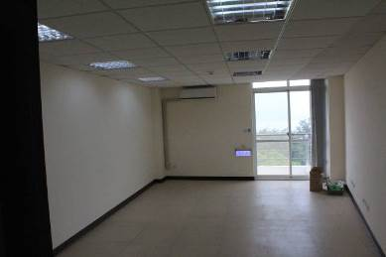 |  | 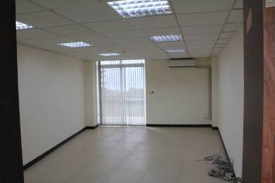 | 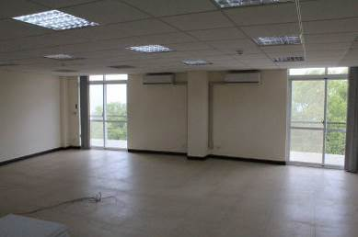

(3) Other public spaces
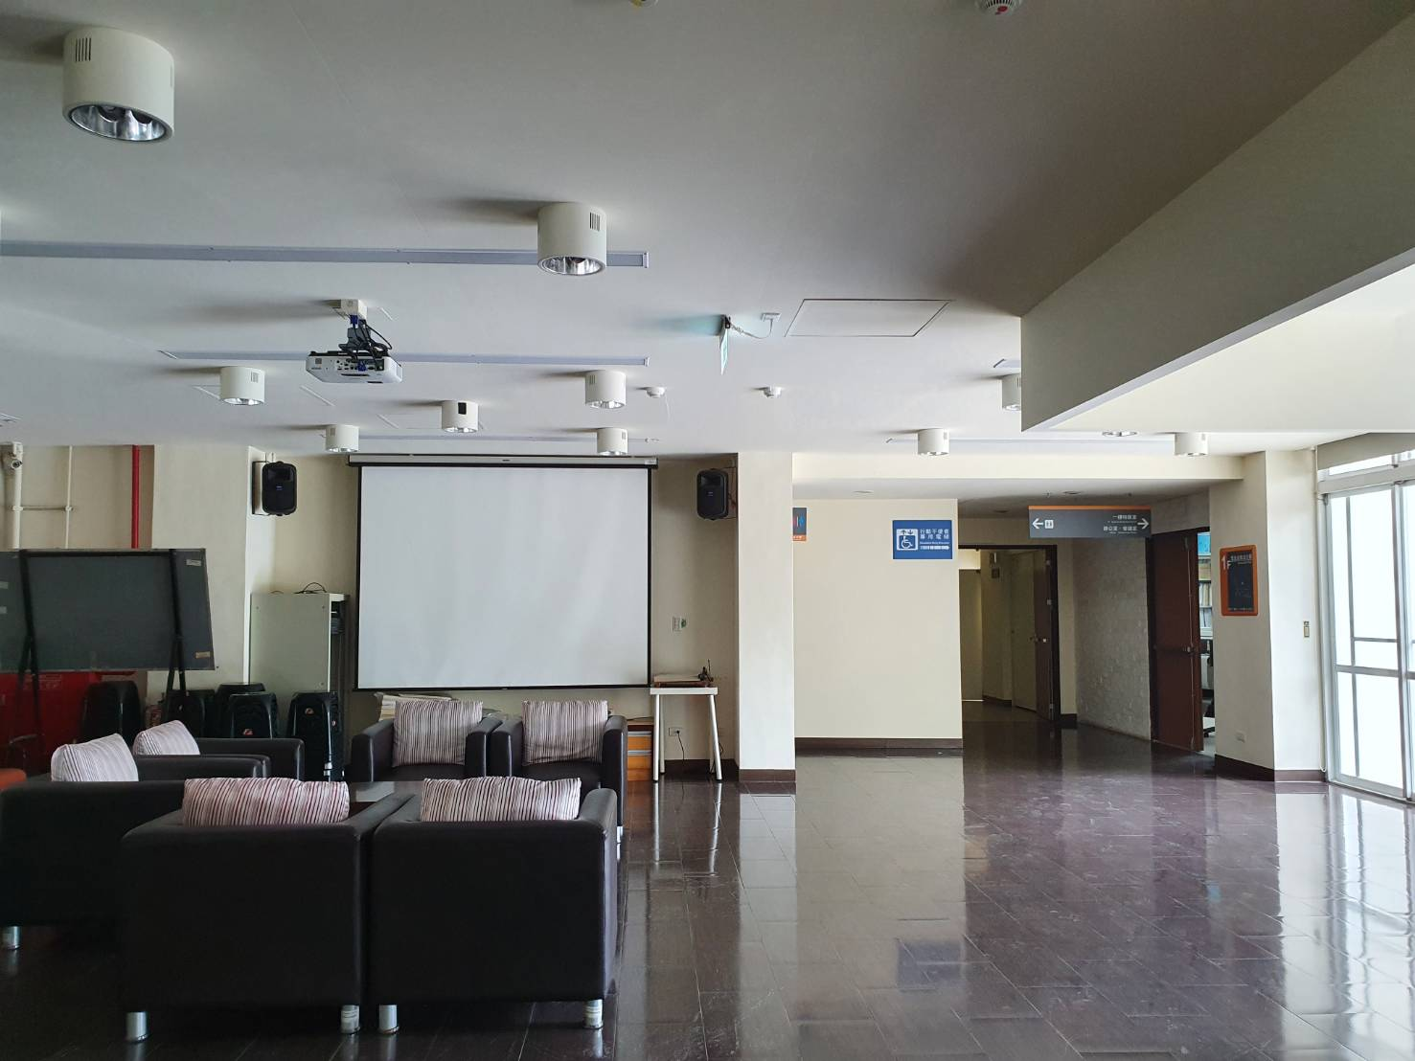 | 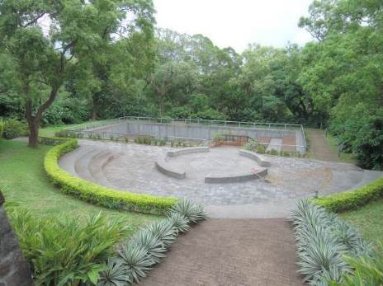
1F Art Exchange Hall | 1F Outdoor theater
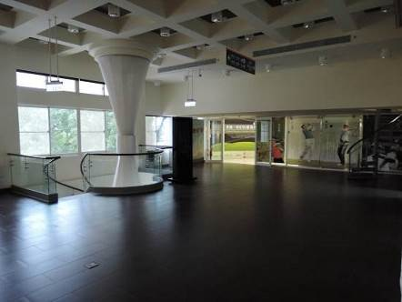 | 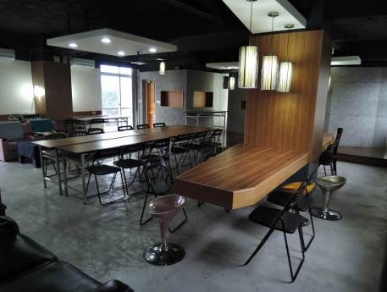
2F Entrance Lobby | 4F Artists Lounge (roughly 80.29 m2)
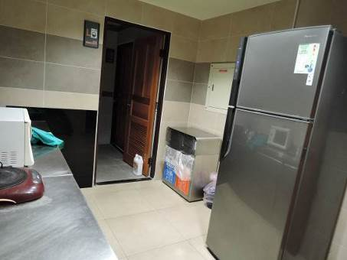 | 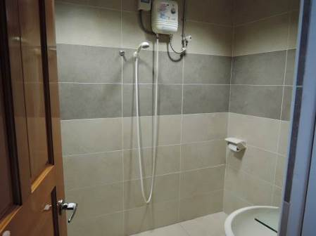
4F Pantry room (water dispenser, refrigerator, washing machine) | 4F Bathroom
(4) Exhibition Space
The Former Residence of Tamsui Township Head Tada Eikichi and the Japanese Police Affairs Dormitories are historical monuments protected under the Cultural Heritage Preservation Act. These buildings were the official residences of Japanese colonial officials and police officers respectively. Both buildings are Japanese-style wooden buildings but their architecture has been adapted to Tamsui’s humid weather and the geographical position of the river bank. The combination of local building materials and architectural elements has also great historical significance.
The Former Residence of Tamsui Township Head Tada Eikichi (Address: No.19, Mackay Street, Tamsui District, New Taipei City)
History introduction foldout download URL: https://reurl.cc/vnMb0o
Visitor’s information: https://reurl.cc/Qdj40Z
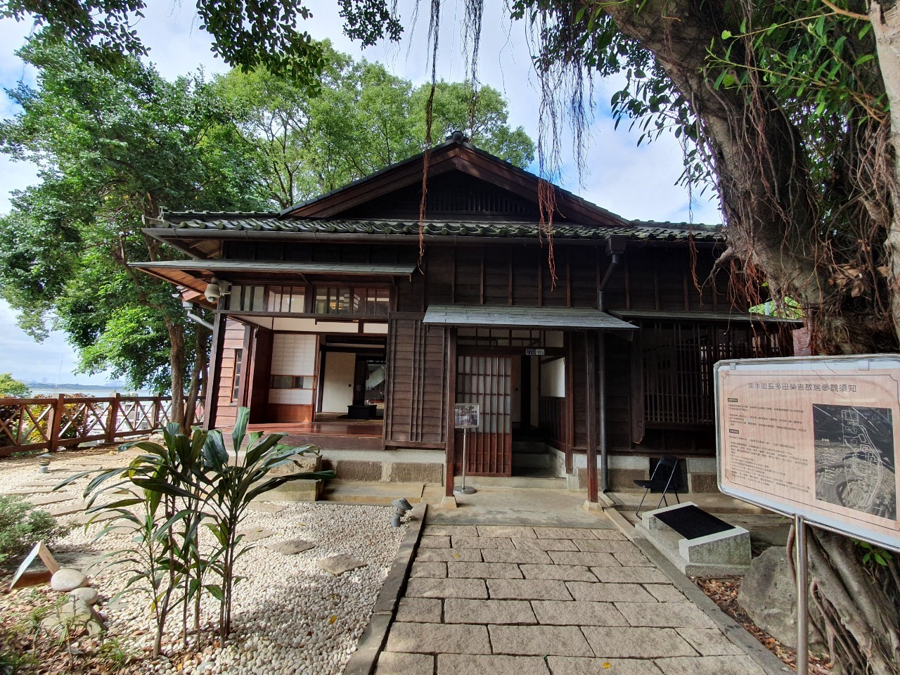
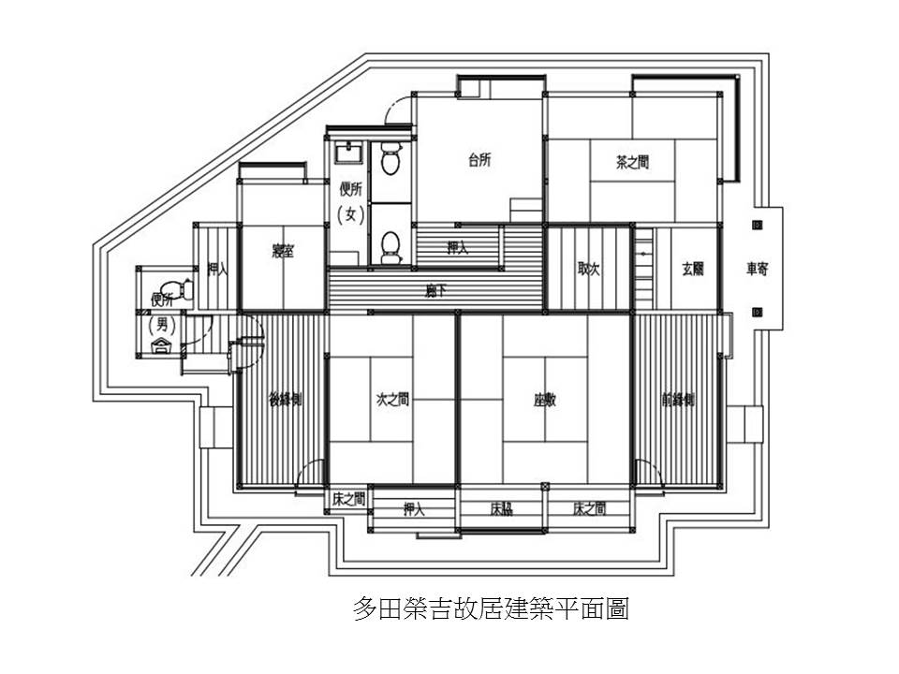

The Japanese Police Affairs Dormitories (Address: No.5, Lane 12, Zhongzheng Road, Tamsui District, New Taipei City)
History introduction foldout download URL: https://reurl.cc/20Wmlm
Visitor’s information: https://reurl.cc/WdD10x
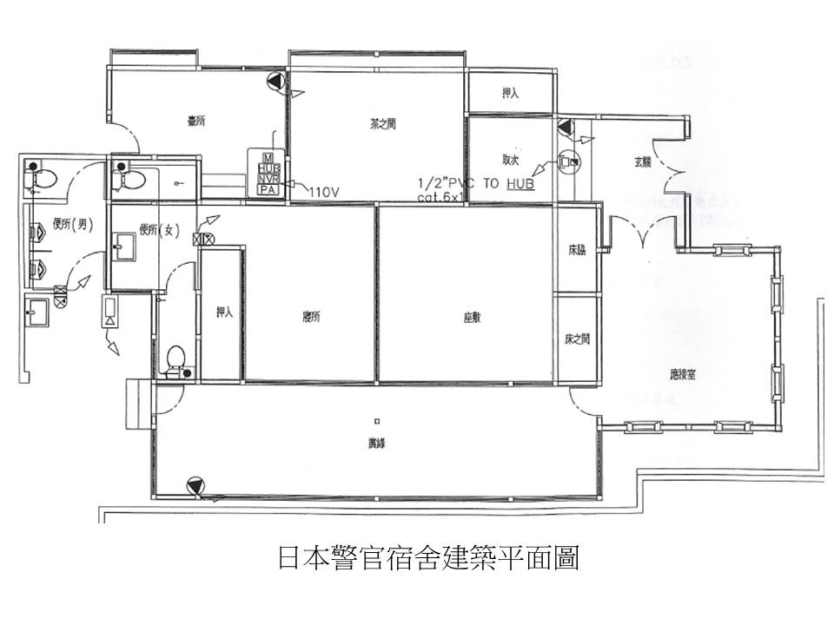
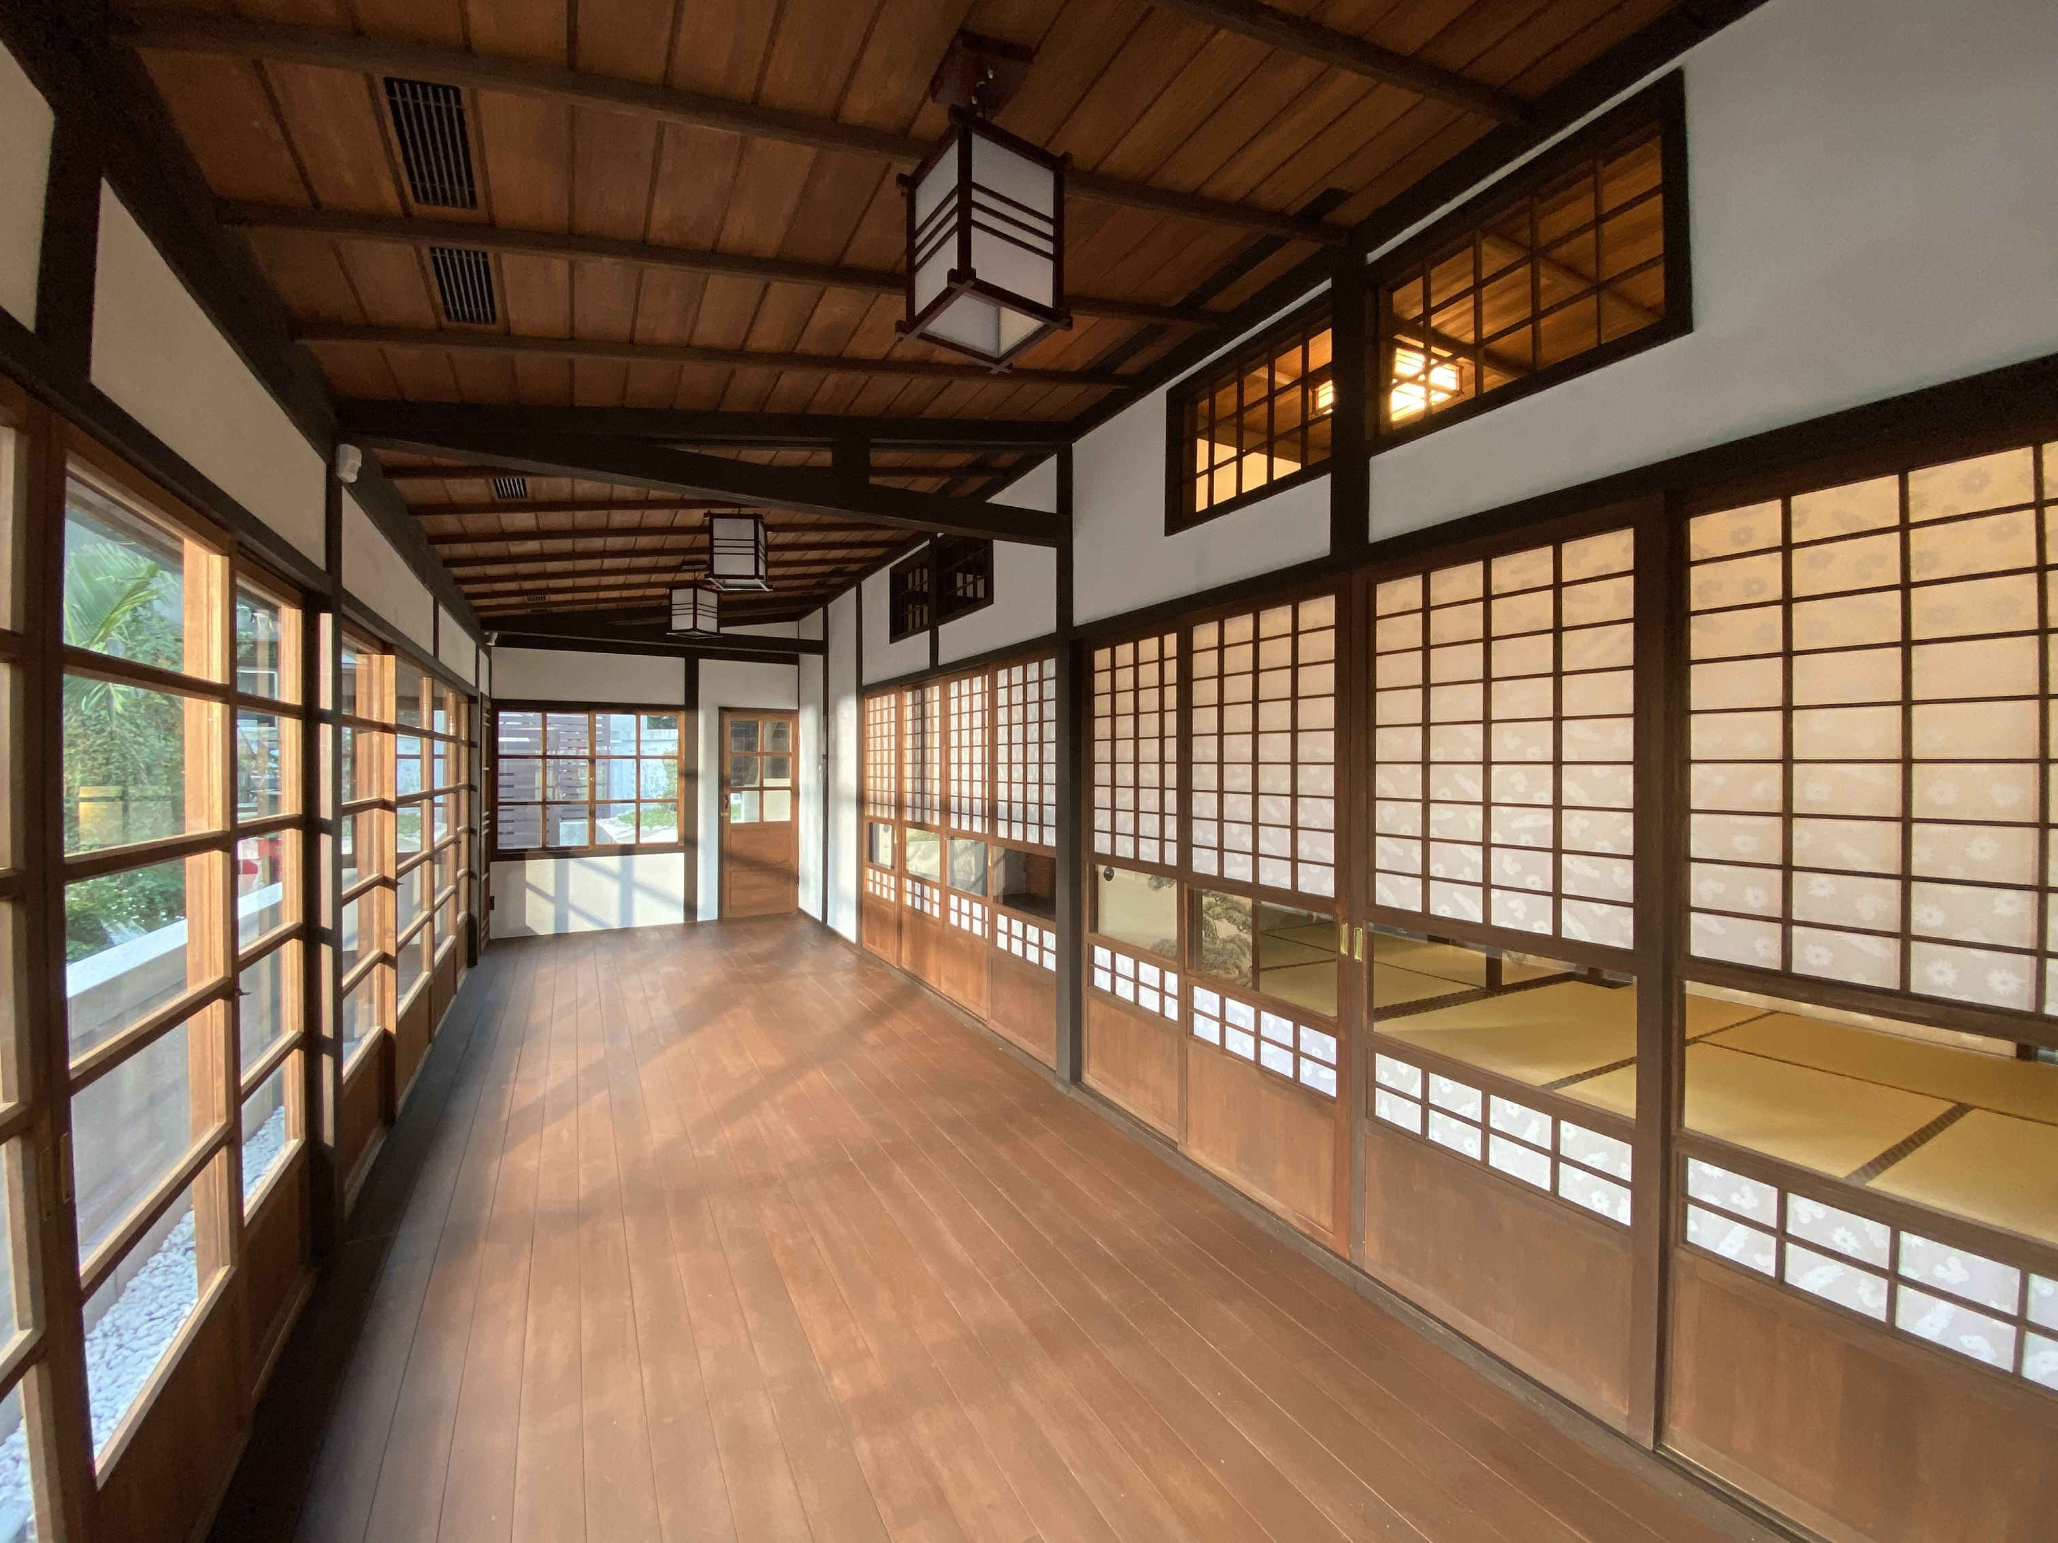

III. Eligibility for application and quota available
          - Independent artists, cultural workers, design employees aged 20 years or older or teams, regardless of nationality, can apply for in-residency. The Number of members in a team is not allowed to exceed four (Foreign individuals who can communicate in Chinese or English are preferred; they must also personally apply for their resident visa and extension).
(2) 8 studios are available for open application (7 small studios and 1 large studio) Foreign artists are guaranteed 1 reserved seat; however, if appraised to be ineligible, the reserved seat will be declared vacant and will be filled by a native artist.
IV. Application time and methods
(1) Deadline: From the date of announcement to 17:00 on (Wednesday) June 3rd, 2020.
(2) Submission method: Fill in the open audition proposal application (including the application form, In-Residence proposal, and portfolio of works for review) are completed as detailed in【Appendix 1】, all applicants shall forward their forms by email under the subject “Application for New Taipei City International Art Village” to ai8704@ntpc.gov.tw.
(3) Other important matters
- Excessively large attachment or photograph files should be uploaded onto a network space or a cloud drive by the applicant. The applicant must also provide the relevant link or address in the application mail. The maximum file attachment size is 300 MB.
- If the applicant does not receive a reply mail from the New Taipei City Government Tamsui Historical Museum after submitting the required documents, the applicant is recommended to call the Museum to confirm it has received the mail.
- Contact Number: (02)2621-2830, ext. 214. Ms. Chen of the Exhibition and Education Section; contact between 9:00–12:00 and 13:30–17:30 from Monday to Friday.
V. Review Methods
(1) Primary review: The Museum reviews all written application documents (including the application form, In-Residence proposal, and portfolio of works for review). Those that do not conform to the requirements will be notified to supplement the required documents to the Museum within a limited period of time. Applicants failing to supplement the required documents within the given period of time will be disqualified.
(2) Secondary review: The review committee reviews the In-Residence applications of applicants who have satisfied the criteria of primary review. The applicant or representative is asked to briefly describe their In-Residence project.
(3) The secondary review time will be individually communicated to the person who has passed the primary review. Those unable to attend will be reviewed in writing.
(4) Review standards
1. Quality and style of works 30%
2. Completeness and feasibility of project 30%
3. Give feedback on the interconnections between creation and creative themes of the project 30%
4. Team experiences (related experience to this project) 10%
5. Those with an average score of fewer than 75 points shall be considered unqualified.
VI. Result announcement
(1) The list of selected artists is expected to be announced in the "Latest News" webpage before (Friday) July 24th, 2020 (subject to the actual operating situation) on the official website of the Taiwan Historical Museum. Each selected party will be notified individually.
(2) If the selected team for in-residency at the NTIAV decides for a period of less than 1 year, the teams on the reserve list will make up for the group in turn in a sequential manner. The replacement team will be notified accordingly at the same time.
VII. In-Residence period
(1) Within the period between September 14th, 2020 and August 31st, 2021, the application for the In-Residence period should be at least 6 months. applicants must fill in the expected duration of In-Residence in the team application documents.
(2) During the In-Residence period, the In-Residence artists may stay overnight in the NTIAV; however, they must return to the NTIAV before the curfew time as stipulated by the Museum.
VIII. Rights and obligations
(1) The selected team must inform of their willingness to take up the In-Residency within 5 days of receiving the notification and complete signing of the In-Residence contract within the stipulated period. Those who fail to finish the required procedure within the period will be disqualified; space will then be attributed to the next artists on the reserve list. The disqualified applicants shall raise no objection. Refer to【Appendix 2】.
(2) Equipment and resources:
1. Studio:
(1)A studio key, an air-conditioning device, Internet, a rack, and a shelf are provided in the room. Desk and chair sets can be provided with a maximum Number of four sets depending on the Number of applicants.
(2)No other equipment or decoration is provided in the space. The In-Residence artists should decorate the space themselves; however, they are not allowed to damage the structure safety or foul up the environment.
2. Public space:
(1)1F: Art Exchange Hall, Conference area, and outdoor theater; 2F: Entrance Lobby; 3F: Large conference room (with projector equipment); 4F: Lounge (with projector equipment); applicants must register for using the facilities with the Museum personnel responsible for In-Residence matters.
(2)4F: Pantry room (including a water dispenser, a refrigerator, and a washing machine) and bathroom. In-Residence artists can use these facilities freely. Foods stored in the refrigerator must be labeled with the owners’ names. The Museum will assign cleaners to clean the refrigerator periodically.
3. Other needs related to work or In-Residence equipment (e.g., easel or hooks) must be informed in the application documents. The Museum will provide necessary supplies as required during the In-Residence period.
4. A provision of NT$10,000 in funds is made for In-Residence Achievement Display and activity-related consumables for each studio. According to the rules of the New Taipei City Government for verification operations, the invoices (receipts) must be produced for reimbursement on actual expenses such as the purchase of materials for exhibitions, feedback activities, printing design, freight, and so on. It does not include personnel costs (such as lecturer expenses, performance expenses), business trip expenses, and transportation expenses.

- The In-Residence art teams shall share part of the water and electricity bill of NTIAV (No. 32-2, Lane 6, Section 1, Zhongzheng Road, Tamsui District, New Taipei City; electricity bill customer Number: 16-61-0108-13-6; water bill customer Number: 1B-21-1331-16-2). In-Residence users in large and small studio rooms shall share 6% and 3% of the bills, respectively. The effective date begins from the day the In-Residence agreement is signed on.
December 2019 to March 2020 Contribution of utilities provided for reference: NT$2,730 for the small studio, NT$5,460 for the large studio.
- Cooperative measures：
(1)During the In-Residence period, the In-Residence artists must participate in the In-Residence Outcome Exhibition and Activities planned by the Museum every year, to be held on the Former Residence of Tamsui Township Head Tada Eikichi and the Japanese Police Affairs Dormitories. In addition, those who are In-Residents for less than a year and will not be able to participate in the Outcome Exhibition and Activities shall be required to give a presentation on their achievement. The Museum reserves the right to coordinate the changes in exhibition venues.
(2)In-residence teams must comply with the NTIAV In-Residence Regulations (Appendix 2) and Daily Activities Agreement (Appendix 3). Facilities and equipment must be checked before and after In-Residence. The equipment list is provided in Appendix 4.
(3)The In-Residence teams shall cooperate with the marketing events arranged by the Museum; they shall receive filming of individual activity for documentaries and interviews.
(4)The In-Residence teams in the large and small studios shall respectively host at least 6 and 4 feedback projects (sessions) every year. The three options are as follows:
1. The artists negotiate the host time and space with the Museum and hold dynamic art and cultural events such as art and cultural education, DIY events, lectures, performance, and workshops free of charge (including in the NTIAV, at Tamsui historical sites and business spots operated by the Museum, or junior high or elementary schools in Tamsui area.
2. The artists shall decorate the inner space of the studio rooms for celebrating festivals including the Chinese New Year, Lantern Festival, International Museum Day, and Christmas. However, since the spaces of the Museum are mostly historical structures, painting, coloring, or renovation works are prohibited.
3. The artists provide design, illustrations, and video-based cultural and creative industry plans free of charge to the Museum to market the local culture. The artists’ works may also be used by the Museum for storage, exhibition, and other educational and promotional purposes.
4. In-Residency for shorter than 6 months is deemed to be counted as 6 months; the feedback sessions are thus halved. Artists in large and small studio rooms shall, therefore, need to host three and two feedback sessions respectively.
(5)Subject to the nature of the In-Residence team, the In-Residence workshop will be made available.
(6)Other matters not covered in this document shall be negotiated by both parties.

【Appendix 1】
New Taipei City International Art Village
In-Residency Recruitment Application Form
Number: (completed by the Museum)
Name of the team: (for individual applicants, the real name, alias, or any preferred name can be filled here)
In-Residence period | From_______________(DD/MM/YYYY) to _______________ (DD/MM/YYYY)  (From September 14th, 2020 till August 31st, 2021; a minimum of 6 months to a maximum of 1 year of  In-Residency, the time should be filled in depending on the applicants’ needs)
Desired studio room Number in order of priority | 1. | 2. |  | 3. |  | 4. |  | 5.
Address of the representative
The email address of the representative
Phone Number of the representative | (Cell phone, office phone, and home phone numbers should be provided as well as the preferred contact time to  facilitate connection)
Photographs of the members  (Passport port photos of 2.9 cm× 3.9 cm or 3.7 cm × 4.8 cm sizes or personal photos or images cut from selfies that can reveal clear facial contour and features can be used. The representative’s photo should be attached to the leftmost cell.) | 
Name
ID card Number
(Resident visa Number for foreign applicants)
Date of Birth
(e.g.,19XX/XX/XX)
Contact Number (cell phone recommended)
Emergency contact person
Relation
Phone Number of emergency contact person
Note: The studio assignment is arranged by the curator according to the selected person's wish and the ranking of the review scores.
Other needs | (e.g., easels, hooks, or any other In-Residence equipment you need)
Applicants’ ID card or passport copies | Please attach the front and back copies of the ID cards (or Alien Resident Certificate or passports for foreign applicants) of all members. Scanning images or photographs uploaded through a computer are acceptable.
Applicants’ ID card or passport copies | (Front) |  |  |  | (Back)
Applicants’ ID card or passport copies | (Front) |  |  |  | (Back)
- After carefully reading the requirements of the application to New Taipei City Government Tamsui Historical Museum, I propose this application in accordance with regulations. If the application is approved, I will follow the relevant regulations as noted.
- I hereby declare that all information and attachments provided in the application documents and proposals are facts.

(Seals of the application unit and applicant)

【Team Name】In-Residency Proposal
- Name of the project
- Project philosophy
- A brief introduction to the applicant team
- Team structure and establishment purpose
- Specialty
- Members’ education background and experience
- Recent outcomes
- Awards
- Content (including feedback projects)
- Items and content introduction of the project
- Space use and In-Residence plans
- Outcome presentation forms
- Feedback projects (holding art and cultural promotion events and feedback projects as listed in the recruitment brochure)
- Expected outcome and effectiveness

※At least 500 words of explanation, combined with photographs and illustrations
- Implementation time (September 2020 to August 2021)
(Space and In-Residence planning and contents of feedback plan implementation are to be provided in the form next page.)
6. Appendix (Registration certificate or proof of holding relevant art and cultural events, such as photographs)
※Not exceeding five A4 pages in principle

New Taipei City International Art Village In-Residence Project Implementation Time Plan
In-Residence period: Artist name:

Year | Month | Item | Specific Practice
2020 | 9
2020 | 10
2020 | 11
2020 | 12
2021 | 1
2021 | 2
2021 | 3
2021 | 4
2021 | 5
2021 | 6
2021 | 7
2021 | 8
※ The size of this form can be adjusted freely.

Portfolio of Works for Review
◎2D/3D works
Category |  | □______ type  □______ type | Attachment | A total of _______________ works
Number | Author name | Work title | Year of creation | Material | Size (H*W) | Picture of the work
1
2
3
4
5
6
7
8
9
10

◎Video/Dance
Work sequence | Author and work name | Year of presentation | Place of release | Brief explanation | Length  (minutes/ seconds)
1
2
3
4
◎Attachment
Downloadable link of the image, video, or audio files.
【Appendix 2】
新北市國際藝術村
駐村協議書
New Taipei City International Art Village
Agreement for In-Residence Program
新北市立淡水古蹟博物館（以下簡稱甲方）________________（以下簡稱乙方）
The New Taipei City Government Tamsui Historical Museum ( hereinafter called Party A)
_____________ _____________________________________( hereinafter called Party B)

為辦理「新北市國際藝術村記憶屋計畫」，經雙方同意，訂定協議書條款如下：
This agreement is made and entered into by and between the parties concerned to carry out the New Taipei City International Art Villa House of Memory Project. The terms and conditions mutually agreed upon are as follows:

- 使用用途
此計畫係提供新北市國際藝術村 工作室(空間範圍詳本進駐計畫簡章)予乙方，乙方得於甲方所指定之前述空間內依核准之進駐計畫書使用之。
Article 1. Usage Purpose
This plan is meant to provide Party B with the Studio Number_______ at the New Taipei City International Art Village (Refer to In-Residence Program Agreement General Rules for the range of spaces). Party B shall use the space according to the In-Residence proposal which has been approved by Party A.

- 使用期間：自____年___月___日至____年____月____日止。
乙方應依申請計畫所提報之進駐期間如期使用，除經甲方同意者外，不得延長；乙方自進駐日起將獲配鑰匙1支，可於進駐期間自由進出國際藝術村，經甲方同意後可複製鑰匙供同組其他創作者使用，鑰匙須妥為保管，並須於辦理離館手續前歸將所有鑰匙(含複製鑰匙)歸還甲方。
Article 2. Period of Use
From dd/mm/yyyy to dd/mm/yyyy.
Party B shall use the space in accordance with the In-Residence proposal applied for and the period of use shall not be extended unless permission is granted by Party A. Party B shall be given a key from the day of residency so as to go in and out the International Art Village freely. Party B may make duplicate keys to share with his/her/its other workers provided Party A permits so. The keys (including the duplicate ones) shall be kept carefully and returned to Party A before Party B checks out.
- 水費與電費分擔
乙方進駐藝術村使用場地，應分擔新北市國際藝術村（新北市淡水區中正路一段6巷32之2號，電號16-61-0108-13-6，水號1B-21-1331-16-2）百分之______的水、電費。
Article 3. Sharing of Water and Electricity bills
Party B shall share ______% of the water and electricity bill of New Taipei International Art Village (No. 32-2, Lane 6, Section 1, Zhongzheng Road, Tamsui District, New Taipei City; Electricity bill customer Number: 16-61-0108-13-6; Water bill customer Number: 1B-21-1331-16-2).
- 房屋使用及維護
- 乙方對使用空間應盡善良管理人之注意義務，如因乙方、或乙方允許在該空間使用收益之第三人故意或過失致房屋毀損、滅失時，乙方應負損害賠償責任。如致第三人遭受損害時，應對於該第三人負損害賠償責任，如因此致甲方遭受損害〈包括國家賠償責任〉時，應對甲方負賠償責任。
- 使用空間之安全，由乙方負責，並應盡善良管理人之責，自行維護進駐空間環境整潔、冷氣機濾網清潔及設施安全，接受甲方及主管機關檢查。
- 乙方使用空間向甲方所借之桌、椅、器材與設備，乙方應盡善良管理人之注意義務，如有毀損、滅失時，乙方應負損害賠償責任。
Article 4. The Usage and Maintenance of the Studio
I. Party B shall treat the studio with the care and duties of a good administrator. Shall Party B or if Party B allows a third party to intentionally or negligently cause the studio to be damaged or lost resulting in a loss of income, Party B shall be liable for damages. In the event the third party suffers prejudice, Party B shall be responsible for damages. In the event Party A suffers prejudice (including State Compensation Liability), Party B shall be liable for damages.
II. Party B shall be responsible for the safety and use of the space while exercising the care of a good administrator and the environmental space shall be kept clean and tidy, the filters of the air conditioners are to be cleaned regularly and the safety of the facilities maintained, which shall be subject to the inspection of Party A and the competent authorities.
III. Party B shall treat with care all the tables, chairs, equipment, and facilities borrowed from Party A while exercising the care of a good administrator. Shall any damage or loss be caused, Party B shall be responsible and compensate accordingly.

- 因天災、事變、特殊傳染性疾病防疫或其他不可抗力事由致無法執行第一條及第二條約定之使用用途時，乙方應即通知甲方，經甲方查明屬實者，本協議書即當然終止，乙方應交回空間。
Article 5. When, as a result of natural disasters, unforeseen events, an epidemic of special infectious diseases or other force majeure reasons, Party B is unable to make use of the space as stipulated in Articles 1 and 2, Party B shall immediately notify Party A. After Party A's verification and if found genuine, the Agreement shall be terminated. Party B shall return the space.
- 空間使用
- 乙方對於空間除依進駐計畫使用外，非經甲方書面同意，不得擅自將空間之全部或部分出租、出借或頂讓他人。違者，甲方得終止協議書外並收回使用空間。
- 甲方有使用或調整空間需求，甲方得保有空間調整之權利，乙方進駐工作室後，甲方仍得要求乙方遷離原本工作室，而搬移至藝術村內其他工作室。
- 藝術村內嚴禁用火，為符合本館節能減碳與生態園區精神，應減少空調使用，若因天候因素（如氣溫達30℃以上）必須開空調，空調溫度請設定攝氏26℃。
- 垃圾應分類處理，並注意週遭環境清潔，廚餘也應放置於廚餘桶內。
- 因藝術村內設備資源（桌、椅、投影設備等）有限，甲方得斟酌館內資源調度提供乙方借用，乙方借用完畢後歸還甲方。
Article 6. Use of Space
I. Party B shall not use the space for any other purpose than that it is planned for and shall not lease, lend or let to others all or part of the space without the consent of Party A. In case of any breach, Party A shall terminate the Agreement and recover the space for use.
II. Party A can have usage or space adjustment needs, Party A shall be able to maintain the right to adjust space. Even after Party B has taken hold of the studio, Party A may still require Party B to move out of the original studio and transfer to other studios in the art village.
III. The use of an open flame is forbidden in the art village. In order to be in line with the spirit of energy conservation, carbon reduction, and ecological maintenance of the Museum, air conditioning shall be reduced. If climatic factors (like temperatures of 30℃ or more), air conditioning must be turned on but set at 26℃.
IV. Party B shall carry out garbage classification and maintain a clean environment. The kitchen waste shall be placed into the Kitchen Waste Bin.
V. Owing to the limited equipment and resources (chairs, tables, projector equipment) in the art village, Party A shall discretionally consider providing Party B with internal resources and Party B shall return them to Party A after use.
- 乙方不得以其協議書之權利作為質押擔保或其他類似使用。
Article 7. Party B shall not use this Agreement as a pledge or guarantee or for similar use
- 乙方場地之使用須符合原提送之進駐計畫使用內容。甲方得不定期查核乙方使用情形，並作為日後申請計畫之重要參考。
Article 8. Party B shall use the space in accordance with the In-Residency plan. Party A shall check the usage of the room from time to time and make the inspection as a reference to other application plans made for the future.
- 提供空間終止使用及賠償
- 有下列情形之一時，甲方得隨時終止乙方使用空間，乙方不得向甲方要求任何補償或賠償：
(一)政府實施國家政策或都市計劃或因開發利用、舉辦公共事業需要或公務需要或依法變更使用者。
(二)乙方使用空間違反法令者。
(三)因可歸責乙方之事由致毀損空間或其他設備而不負責修復者。
(四)房屋因可歸責於乙方之事由致焚毀者。
(五)乙方擅自增建、改建或修建者。
(六)乙方違反本協議書之約定者。
(七)其他依法令規定，得終止協議書者。
- 乙方如有違約情事者，除另有約定外，應負損害賠償責任，乙方如有數人，負連帶賠償責任。
- 乙方終止使用空間前，需事先詢問甲方是否依現狀交付，除本協議書另有約定或經甲方同意依現狀交還外，乙方應將使用空間回復原狀返還甲方。
- 乙方於協議書終止或使用期限屆滿協議書關係消滅時，乙方應於屆滿當日將空間交返甲方。其留置物品經甲方通知限期仍不搬離者，視為廢棄物，任憑甲方處理，其清除處理費用由乙方負擔。
Article 9. Termination of the Provision of Space and Compensation.
I. Party A shall have the right to terminate Party B’s usage of the space in the case of any one of the following circumstances and Party B may not ask for reparation or compensation from Party A:
(1)The government implements state policies or urban plans or, as a result of development needs, carries out public utility needs or exigencies of service or make changes in accordance with the law.
(2)Party B uses the space against the laws and regulations.
(3)Party B damages the space and other equipment and refuses to restore the damage caused.
(4)The studio is burnt due to the responsibility attributed to Party B’s misconduct.
(5)Party B carries out the construction, renovation, or reconstruction without authorization.
(6)Party B violates any of the terms stipulated in this agreement.
(7)This agreement shall be terminated in accordance with certain laws and regulations.
II. Shall Party B make a breach of contract, he/she/it shall be responsible for the damages and compensation unless otherwise agreed upon. If Party B includes several persons, they shall be jointly and severally liable for damages.
III. Prior to Party B terminating the use of space, Party B shall ask Party A whether or not to deliver the space in accordance with the present situation. Unless otherwise stipulated in this agreement letter or if Party A consents it to be returned it in accordance with the present situation, Party B shall, then, return the space to Party A, in its original state.
IV. Party B shall return the space to Party A on the date the agreement shall be terminated or expires. In the event Party B has not taken out his/her/its remaining belongings within the time limit after Party A's notification, they shall be deemed to be abandoned. Party A will dispose of it and Party B shall be responsible for the clearance and processing expenses.
- 乙方於使用期間內擬提前終止使用空間者，應於15日前以書面向甲方提出申請，經甲方書面同意後，使得終止本協議，乙方不得向甲方要求任何補償或賠償。
Article 10. Shall Party B intends to terminate the use of the space in advance, Party B shall submit a written application, to Party A, 15 days beforehand and the Agreement shall be terminated if Party A consents to it. Party B shall not ask Party A for any reparation or compensation.
- 乙方應擔保其著作及申請計畫無侵害他人著作權之情事，若此情形發生致使甲方名譽遭受損害或受連帶賠償請求之損失，由乙方負全部賠償責任。
Article 11. Party B shall guarantee that his/her/its creations and project application do not infringe upon the copyrights of others. Shall such a situation arise and results in the loss of Party A's reputation or in a claim of compensation from Party A, Party B shall be fully liable for all the damages caused and make the compensation accordingly.
- 配合辦理事項：
- 駐村期間，每年需參與甲方辦理之駐村成果展示及活動；另駐村期間未滿一年者，未能參與駐村成果展示及活動，需辦理成果發表。
- 採訪紀錄：甲方為推廣、行銷目的所採訪之錄影、錄音、照片及文字紀錄，著作財產權歸甲方所有，乙方同意授權甲方活動宣傳、公關報導與展示之用。
- 進駐之團隊，大工作室每年至少辦理6（場）次之回饋計畫，小工作室每年至少辦理4（場）次之回饋計畫。駐村期間未滿半年者，以半年計，回饋場次減半。
- 如因天災、事變、流行病防疫政策或其他不可抗力事由，致前述配合辦理事項難以執行，雙方得合意調整配合辦理事項內容。
Article 12. Cooperation Matters
I. During the period of In-Residency, it shall be necessary to participate in the In-Residence Outcome Exhibition and Activities organized by Party A every year; for those residents who/which have been in the village for less than one year and are unable to participate in the In-Residence Outcome Exhibition shall hold an outcome presentation instead.
II. Party B agrees to authorize Party A to disseminate publicly, report, and display its activities for promotional and marketing purposes; the property rights of the video, audio recordings, photos, and written records of the interviews shall belong to Party A.
III. During the period of In-Residency of the art and cultural creative teams, the large studios shall host at least 6 Feedback Projects yearly and the small studios, 4 Feedback Projects yearly. For those teams with less than half-year residency, it will be considered as a half-unit, thus the Number of Feedback Projects to be hosted shall be halved.
IV. If the above-mentioned matters are difficult to implement due to natural disasters, incidents, epidemic prevention policies or other force majeure matters,
the parties may agree to adjust the contents of the matters to be handled.
- 爭議處理：
    - 本協議書雙方應依誠信原則確實履行，如有涉訟，以臺灣新北地方法院為管轄法院。
    - 如因乙方違反本協議涉訟，甲方所支付之訴訟費及律師費概由乙方負擔。
Article 13. Dispute Settlement.
I. Both parties shall abide by this agreement based on the principle of integrity. In the event of any litigation, the Taiwan New Taipei District Court shall be chosen as the jurisdiction court.
II. In the case a lawsuit is filed against Party B as a result of its breaching the Agreement, all the legal costs and attorney's fees shall be borne by Party B.
- 本協議書如有未盡事宜，依善良、友好、公平、合理之原則解釋之。
Article 14. In the event of any matter not covered in this Agreement arises, it shall be dealt in accordance with the principles of kindness, friendliness, fairness, and reasonableness.
- 「新北市國際藝術村記憶屋計畫－駐村藝術家徵選申請簡章」及乙方所提供之文件資料經甲方同意者為本協議書之一部份。
Article 15. The "New Taipei City International Art Village House of Memory Project – Prospectus for In-Residence Open Audition Application" and the documents provided by Party B following the approval of A shall form part of this Agreement.
- 本協議書得經立約人同意後，以書面修正或補充之。
Article 16. This agreement may be amended or supplemented upon the consent of both parties.
- 本協議書一式四份，正本二份、副本二份，經立約人簽章後生效。正本由甲、乙方各執乙份，副本由甲方保管。
Article 17. This agreement is made in quadruplicate, two originals and two copies, and becomes effective upon the apposition of the signatures and seals of both the parties concerned. Both parties shall keep one copy of the original agreement and Party A shall keep the two duplicate copies.
甲 方：新北市立淡水古蹟博物館
代 表 人：柏麗梅館長
地 址：新北市淡水區中正路1段6巷32-2號
電 話：02-2621-2830
Party A: New Taipei City Government Tamsui Historical Museum
Representative: Po, Li-Mei
Address: No.32-2, Lane 6, Section 1, Zhongzheng Road, Tamsui District, New Taipei City
Telephone: 02-2621-2830

Party B: (Signature of Representative)
Address:
Telephone Number:

中華民國109年 月 日
This ___ th day of ______________, 20_______
【Appendix 3】
新北市國際藝術村駐村生活規約
New Taipei City International Art Village In-Residency Regulations

- 本館保全時間目前為24小時，駐村團隊出入藝術村，應配合本館保全門禁時間，晚上11時45分至早上6時之間，禁止出入藝術村，若有緊急狀況(如身體不適掛急診、孕婦生產…等)，請於第一時間通知本館人員後，方可進出。
The Museum is under the control of 24-hour security guards every day. The In-Residence team should comply with the curfew time of the Museum. No access to the Museum is permitted from 23:45 to 06:00. In case of any emergency (e.g., need for emergency medical services or pregnant women going into labor), the team must notify the Museum personnel immediately to open the entrance.

- 就本館藝術村1樓藝術交流大廳、1樓與3樓會議室，及4樓藝術家交誼廳等場地借用，4小時以內短時段之場地借用，請於場地使用日3日前向本館承辦人員申請；超過4小時至2日以內場地借用，前1週向本館承辦人申請；超過2日之長時段場地借用，前2週向本館承辦人申請。
For use of the Art Exchange Hall on the first floor, conference areas on the first and third floors, and the Lounge on the fourth floor for shorter than 4 hours, the applicants must issue the application to the responsible personnel 3 days in advance. If the use duration is between 4 hours and 2 days, the applicants must apply for the application 1 week in advance. For long-term use over 2 days, the applicants must apply for using the areas 2 weeks in advance.

- 駐村團隊如欲使用2樓大廳辦理講座或工作坊活動，請於前1個月前向本館承辦人申請。
If an In-Residence team intends to use the Lobby on the second floor to hold lectures or workshop events, they must apply to the responsible personnel a month in advance.

- 駐村團隊使用場地應維持環境整潔與安寧，避免影響他人；週一至週五中午12時30分至下午1時30分為館方行政人員午休時間，駐村團隊使用場地應降低音量。
When In-Residence teams use public spaces, they must keep environmental cleanliness and discipline in order to avoid disrupting others. The period of time from 12:30 to 13:30 from Monday to Friday is the lunch break of the Museum’s administrative personnel; In-Residence teams using the public spaces during this time period should lower their voice volume.
- 駐村團隊可自行使用4樓冰箱，並請於保鮮期內食用完畢，本館清潔人員將每2週定時清理冰箱；另因本館活動或清潔需移動冰箱內存放物，請駐村單位配合館方人員指示。
The In-Residence teams can freely use the refrigerator on the fourth floor. Foods should be consumed before expiration. The cleaners of the Museum periodically clean the refrigerator biweekly. If the Museum needs to move stocks in the refrigerator because of any Museum event or cleaning requirement, the In-Residence teams should comply with the instructions of the Museum personnel.

- 藝術村內每月一次不定日進行公共空間環境消毒，若駐村單位於藝術村內遇上消毒人員行消毒施作，為避免駐村團隊吸入消毒水影響健康，請配合消毒人員指示，離開藝術村或待於藝術家工作室中。
NTIAV undergoes environmental disinfection of the public spaces once a month at a date to be announced. If the In-Residence teams encounter disinfection practices in NTIAV, they should follow personnel’s instructions to leave NTIAV or stay in their studio rooms to avoid inhalation of the disinfectant chemicals that may compromise their health.
- 駐村團隊使用工作室，請維持環境清潔並定期清理垃圾，並統一置於藝術村4樓定點垃圾桶（一般垃圾、資源回收與廚餘），另避免自外攜帶垃圾至館內丟棄。
The In-Residence teams should maintain the environmental cleanliness of the studio room and remove their garbage periodically. Trash, recyclable resources, and leftovers should be placed at a fixed spot on the fourth floor of NTIAV. The teams should not bring garbage from outside and discard it in the Museum.

- 藝術村內全面禁菸，並請駐村團隊減少高負載電力設備之使用，以避免造成藝術村跳電。
NTIAV is a comprehensively non-smoking area. All In-Residence teams should refrain from using devices with high electrical loads to avoid power failure.

The In-Residence team(駐村團隊)___________________ agrees on following the regulations as stated herewith in the New Taipei City International Art Village In-Residence Regulations.
Representative(立書人): (Signature of Representative)
【Appendix 4】 新北市國際藝術村
工作室使用設備清單
New Taipei City International Art Village
Studio room ______’s equipment and facility list

In-Residence team name(駐村團隊名稱):
In-Residency period(駐村日期):

借用物品 | 借用日期 |  | 借用人  簽收 |  | 館方人員簽收 |  | 歸還日期 |  | 借用人  簽收 | 館方人員簽收 | 備註
Borrowed item |  | Date of borrowing |  | Signature of the borrower |  | Signature of the Museum personnel |  | Date of return | Signature of the borrower | Signature of the Museum personnel | Note
工作室鑰匙 支
Key of the studio room
Quantity:
冷氣遙控器 支
Air-conditioning remote control
Quantity:
桌子 張
Table
Quantity:
折疊椅 張
Folding chair Quantity:
衣櫃 組
Closet
Quantity:
座墊椅 個
Chair with cushion Quantity:
置物架 個
Shelf
Quantity:

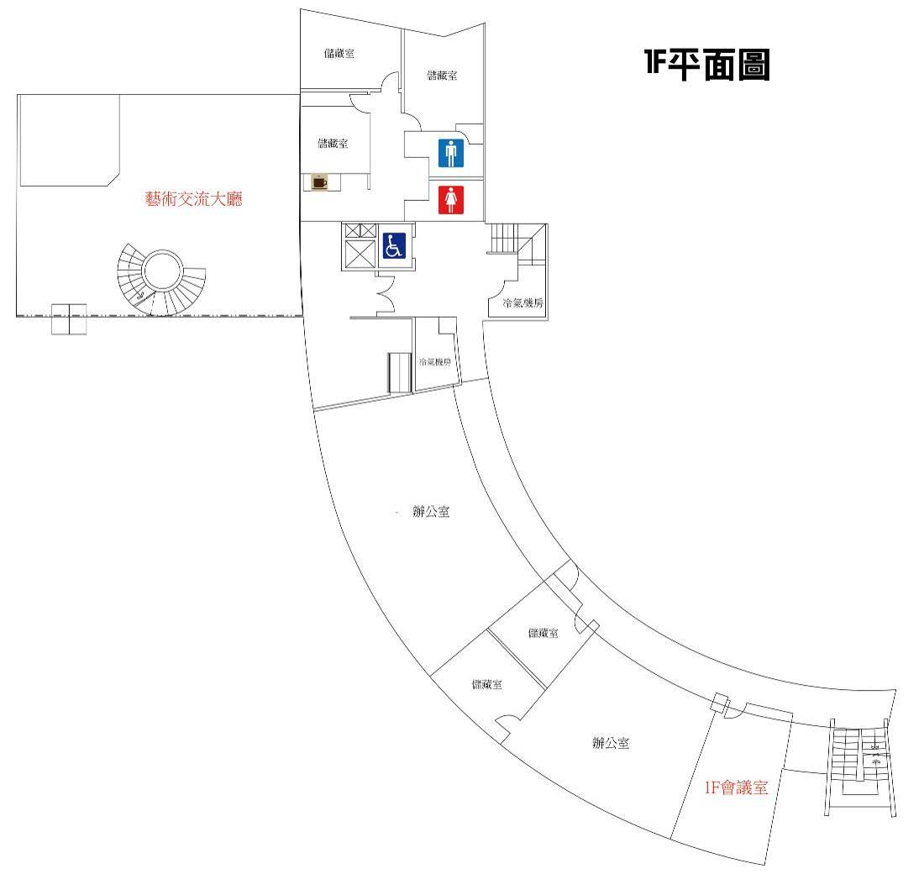
辦公室


