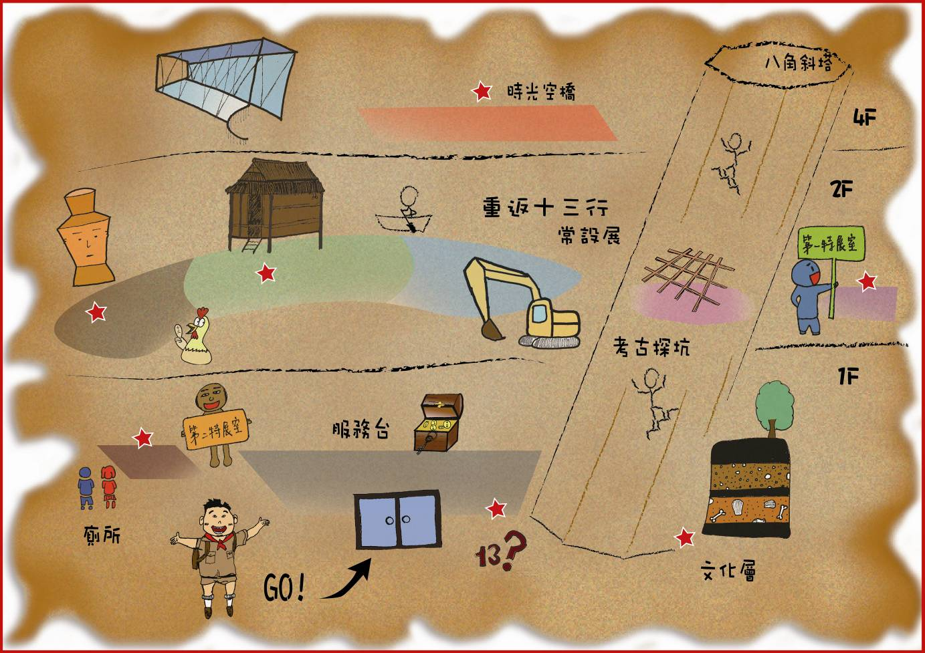
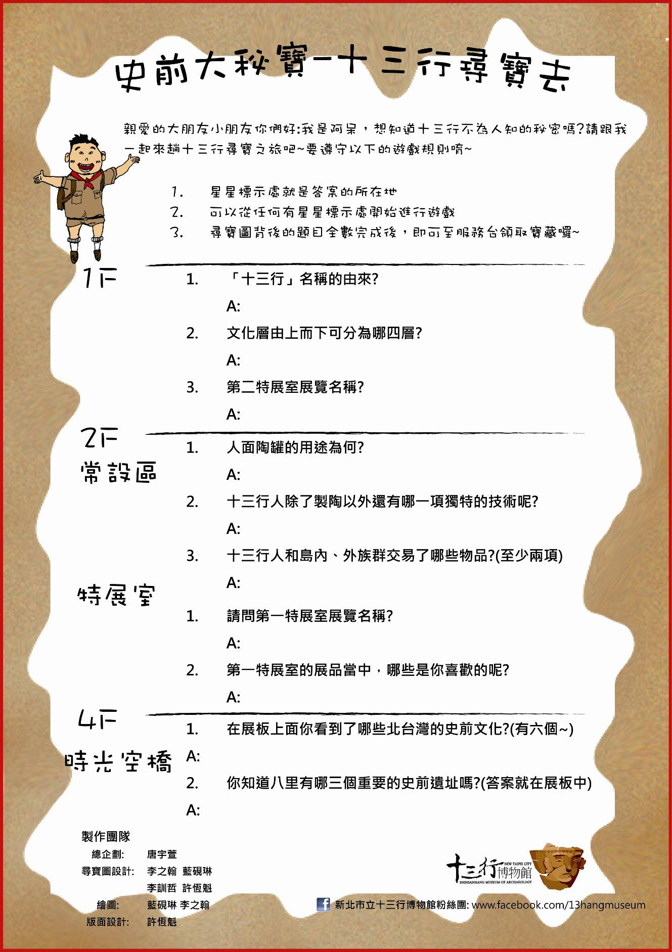史前大秘寶-十三行尋寶去
1F
- 十三行名稱如何來?
A:
- 文化層由上而下可分為哪四層?
A:
- 第二特展室展覽名稱?
A:
2F(常設區)
- 人面陶罐的用途為何?
A:
- 十三行人除了製陶以外還有哪一項獨特的技術呢?
A:
- 十三行人和外來民族交易些什麼東西?
A:
2F(特展室)
- 請問第一特展室展覽名稱?
A:
- 第一特展室的展品當中，哪些是你喜歡的呢?
A:
4F(時光空橋)
- 在展板上面你看到了哪些北台灣的史前文化?(有六種喔~)
A:
- 你知道八里有哪三個重要的史前遺址嗎?(答案就在展板中唷)
A:
親愛的大朋友小朋友你們好:我是阿呆，想知道十三行不為人知的秘密嗎?請跟我一起來趟十三行尋寶之旅吧~要遵守以下的遊戲規則唷~

- 星星標示就是答案的所在地
- 可以從任何有星星標示處開始進行遊戲

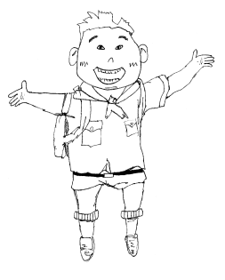
Big Historical Treasure-Let's Go to Shihsanhang
1F
- Where did the name "Shihsanhang" originate from?
A:
- What four layers do the "Cultural Wall" consist of?
A:
- What is the name of the Second Special Exhibit?
A:
2F("Back to Shihsanhang" Permanent Exhibition)
- What was the famous "Anthropomorphic Jar" (the jar that is the museum's logo) used for?
A:
- Aside from their talent in ceramic making, what other unique skills did the Shihsanhang people have?
A:
- What types of goods did the Shihsanhang people trade with outsiders? (Name at least two)
A:
2F(Special Exhibitions)
- What is the name of the First Special Exhibition?
A:
- Of all the exhibits in the First Special Exhibition, which do you like the most?
A:
4F(Time Bridge)
- On the display boards in the "Time Bridge", which prehistoric cultures are introduced? (There are six of them)
A:
- Do you know what are the three important prehistoric sites in Bali? (Hint: The answers can be found in the panel descriptions)
A:
My dear kids, big or small - my name is Ah-Ben. Would you like to know the long-hidden secret of Shihsanhang? If so, then please accompany me on this Shihsanhang treasure hunt trip~Please follow the rules below to ensure that you have a fun time~

- Stars on the map indicate where answers to the above questions can be found
- You can start this treasure hunt trip from any star you wish
- Once you answer all the questions on this page, bring your treasure map to the Information Desk, where you will receive a treasure of your own.

Production Team
Head Planner:Angele Tang
Treasure Map Design: Laurence Lee, Lan Yen Lin, Li Xun Zhe, Xu Heng Kui
Illustration & Art: Xu Heng Kui, Lan Yen Lin, Laurence Lee
Words & Layout: Li Xun Zhe Facebook Fan Group Page:www.facebook.com/13hangmuseum

